Discussion Session on DC circuits

Problem 1 on resistance dependence on temperature
The resistivity of tungsten increases approximately linearly from 56 nΩ ⋅ m at 293 K and 1.1 μΩ ⋅ m at 3500 K. Estimate (a) the resistance and (b) the diameter of a tungsten filament used in a 40 W bulb, assuming that the filament temperature is about 2500 K and that a 100 V dc supply is used to power the light bulb. Assume that the length of the filament is constant and equal to 0.5 cm.

Problem 2 on Direct-Current circuits

In the circuit in the figure, the reading of the ammeter is the same with both switches open and both switches closet. Find the resistance R.

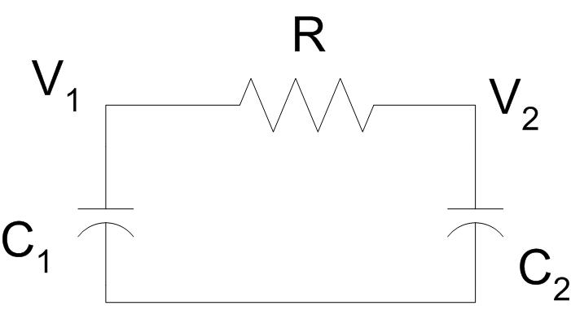
Fig. Problem n. 2 Fig. Problem n. 3 Fig. Problem n. 4

Problem 3 on RC Circuits

The capacitors in the figure are initially uncharged. A) What is the initial value of the battery current when switch S is closed? B) What is the battery current after a long time? C) What are the final charges on the capacitors?

Problem n. 4 on RC circuits

A capacitor with capacitance C₁ = 100 μF, charged with a potential difference ΔV = 1200 V, is connected through a resistor R = 10⁵ Ω to a second capacitor, initially uncharged, with the same (C₁ = C₂). Calculate:
- the final value of the potential difference between the plates of the first capacitor;
- the energy dissipated through R during this process;
- the time it takes to have that the potential differente on the second capacitor is 30% of its final value.

